Automatic bidirectional visitor counter using 8051 microcontroller (AT89C51)
MC014
- Summary
- Description
- Circuit Diagram
- Video
- Code
- Components
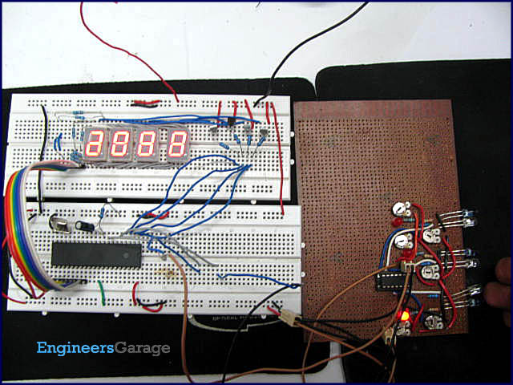
A counter that can change its state in either direction, under control of an up–down selector input, is known as an up–down counter. The circuit given here can count numbers from 0 to 9999 in up and down modes depending upon the state of the selector. It can be used to count the number of persons entering a hall in the up mode at entrance gate. In the down mode, it can count the number of persons leaving the hall by decrementing the count at exit gate. It can also be used at gates of parking areas and other public places.
This circuit divided in three parts: sensor, controller and counter display. The sensor would observe an interruption and provide an input to the controller which would run the counter in up/down mode depending upon the selector setting. The same count is displayed on a set of 7-segment displays through the controller.
In this circuit, two infrared (IR) sensor modules are used each for up and down counting, respectively. Whenever an interruption is observed by the first IR sensor, it increments the counter value. Similarly, when the second sensor detects an obstacle, the count is decremented.

The count value is calculated depending upon the sensors’ input and is displayed on a set of four seven segment displays by using the concept of multiplexing (for concept of multiplexing refer seven segment multiplexing). The data pins of each 7-segment display are connected to port P₂ of the microcontroller AT89C51. The first four pins of port P₁ (P₁^0-P₁^3) are connected to control pins to enable a particular 7-segment
. P₁^5 & P₁^6 are configured as input pins at which the sensors are connected.

The sensor inputs are defined as up and down selector modes for the counter in the code. Each time the first sensor is blocked, it gives a high signal at P₁^5 and the count value gets incremented. The value gets decremented when P₁^6, connected to second sensor, gives high input. At each step, the value of the counter is sent to be displayed on the segments.
// Program to make a bidirectional visitor counter using IR sensor

#include <reg51.h>
#define msec 1
unsigned int num=0;
sbit dig_ctrl_4=P1^3; //declare the control pins of seven segments
sbit dig_ctrl_3=P1^2;
sbit dig_ctrl_2=P1^1;
sbit dig_ctrl_1=P1^0;
unsigned int digi_val[10]={0x40,0xF9,0x24,0x30,0x19,0x12,0x02,0xF8,0x00,0x10};
unsigned int dig_1,dig_2,dig_3,dig_4,test=0;
unsigned char dig_disp=0;
sbit up=P3^5; //up pin to make counter count up
sbit down=P3^6; //down pin to make counter count down

void init() // to initialize the output pins and Timer0
{
up=down=1;
dig_ctrl_4 = 0;
dig_ctrl_3 = 0;
dig_ctrl_2 = 0;
dig_ctrl_1 = 0;
TMOD=0x01;
TL0=0xf6;
TH0=0xFf;
IE=0x82;
TR0=1;
}

void delay() //To provide a small time delay
{
TMOD=0x01;
TL0=0x36;
TH0=0xF6;
TR0=1;
while(TF0==0);
TR0=0;
TF0=0;
}

void display() interrupt 1 // Function to display the digits on seven segment. For more details refer seven segment multiplexing.
{
TL0=0x36;
TH0=0xf6;
P2=0xFF;
dig_ctrl_1 = dig_ctrl_3 = dig_ctrl_2 = dig_ctrl_4 = 0;
dig_disp++;
dig_disp=dig_disp%4;
switch(dig_disp)
{

case 0:
P2= digi_val[dig_1];
dig_ctrl_1 = 1;
break;

case 1:
P2= digi_val[dig_2];
dig_ctrl_2 = 1;
break;

case 2:
P2= digi_val[dig_3];
dig_ctrl_3 = 1;
break;

case 3:
P2= digi_val[dig_4];
dig_ctrl_4 = 1;
break;
}
}

void main()
{
init();
while(1)
{
if(up==0&&down==1) //check if up pin is pressed
{
test++;
num=test;
dig_4=num%10;
num=num/10;
dig_3=num%10;
num=num/10;
dig_2=num%10;
dig_1=num/10;
if(test==9999)
test=0;
}
if(up==1&&down==0) //check if down pin is pressed
{
test--;
num=test;
dig_4=num%10;
num=num/10;
dig_3=num%10;
num=num/10;
dig_2=num%10;
dig_1=num/10;
if(test==0)
test=9999;
}
}
}
